MEHRAN UNIVERSITY

OF ENGINEERING & TECHNOLOGY

JAMSHORO, PAKISTAN

To understand static routing. Design the required network and configure the static routing.

Subject: COMPUTER NETWORKS (PR)

(Lab 7 - Tasks Solution)

|  |  |
| --- | --- |
| **Roll No:** | **22SW028** |
| **Section:** | **I** |

**LAB TASKS:**

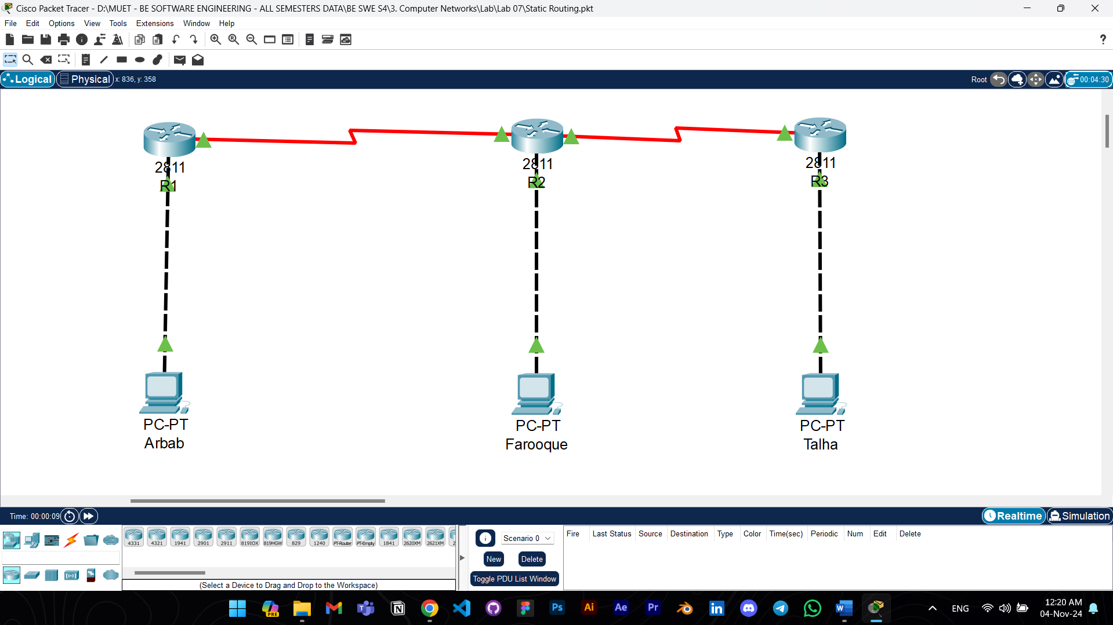

This network was built according to the instructions given in the lab manual. The network uses static routing and is tested with the ping commands from each PC and everything’s working as expected.

Answers to the questions given in Lab Manuals are below.

**Answers to Questions:**

**1. Why is the interface serial0 changed to down?**

Ans: The serial interface might go down if the other end of the connection (on the neighboring router) is not configured or is also down. That’s why its state was changed to UP as well.

**2. Why have the hosts been assigned the same network IP addresses?**

Ans: The hosts connected to each router have been assigned IP addresses in the same subnet as their respective router interfaces (e.g., 192.168.1.0/24 for Router1). This allows each PC to communicate with its directly connected router. Using the same network addresses on each side of the router is necessary for the routers to identify and forward traffic within those subnets.

**3. Are all the necessary interfaces up?**

Ans: Yes, the interfaces of all routers are up.

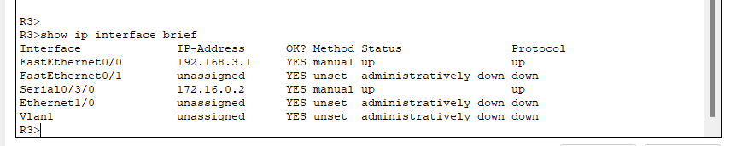

**4. Can a host on subnet 172.16.0.0 see a host on network 192.168.3.0?**

Ans: No, a host on 172.16.0.0 cannot see a host on 192.168.3.0 without static routes configured on the routers. Static routing must be set up to inform each router how to reach other subnets in the network.

**5. Why are three static routes needed on Router1 and Router3?**

Ans: Three static routes are needed because each router must have a path to each remote subnet that it is not directly connected to. For example, Router1 needs routes to reach the subnets on Router2 and Router3 (192.168.2.0, 192.168.3.0, and 172.16.0.0) for successful end-to-end communication.

**6. List the routes listed in the routing table**

Ans:

R1:

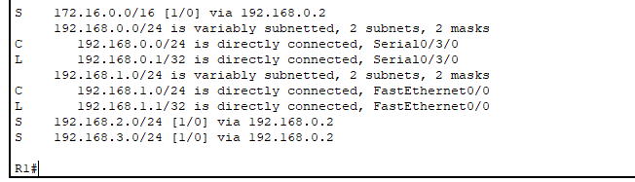

R2:

R3:

**7. What is the administrative distance?**

Ans: The administrative distance for a static route is 1, which indicates a high level of trust in the route since it was manually configured by an administrator. This distance is lower than dynamic routing protocols, making static routes preferred when available.